Minutes of Ormesby St Margaret with Scratby Parish Council meeting held on Monday 11th July 2022 at 7pm at All Saints Parish Hall Scratby.
Present: Cllrs: Andy Grant (Chair) Justin Rundle (Vice Chair) Robert Hill, Mick Cheetham, Phil Nathan, Sylvia Bigg, Peter Holley, Kathryn Wendt (1st minute taker) Geoff Freeman (2nd minute taker) Jim Shrimplin and John Green.

The Chair welcomed Councillors, County Councillor James Bensley and Borough Councillors Ron Hanton and Geoff Freeman and members of the public. He alluded to the fact that we are in Scratby and not Ormesby as advertised.

- To receive apologies for absence: Simone Calnon, Robert Hirst.

- To receive declarations of interest on matters on the agenda. You have a Disclosable Pecuniary Interest in a matter to be discussed if it relates to something on your Register of Interests form. You must declare your interest; you may not participate in discussion or vote on the matter. You have a Personal Interest in a matter to be discussed if it affects:

• Your wellbeing or financial position
• That of your family or close friends
• That of a club or society in which you have a management role
Cllrs Andy Grant and Sylvia Bigg declared an interest under Finance.

- The minutes of the Parish Council meeting of 13th June 2022 were unanimously agreed. Proposed by Cllr Andy Grant and Seconded by Cllr Peter Holley.

- Borough Councillor’s Reports: Cllr Ron Hanton’s report had been sent to councillors via email prior to the meeting. Cllr Geoff Freeman stated that he had been away on holiday so no Report for this meeting. Cllr Peter Holley raised the issue of the Caister-on-Sea development which was passed by Great Yarmouth Development Control 6th June 2022. Cllr Geoff Freeman said that the development was already on the Town Plan 2008 and thought that it was always going through. Cllr Ron Hanton said that he voted against the development as he knew what the traffic congestion was like before the bypass was installed.

- County Councillor’s Report: Cllr James Bensley added to his report:
W/B 1st August 2022 the weeds by the side of the roads is scheduled to be done.
California Road now has a 40mph limit sign. Cllr Peter Holley thanked Cllr Bensley for his work in getting this done.
Bus service improvement Plan- 0344 800 8020 for a paper copy.
Cut-Price compost bin- orlo.uk/Mlkfr
Trees for life 50% subsidy- orlo.uk/m28C6
Norfolk warm homes grant- 01603 430 103
Public Participation Forum– an opportunity for the public to address the council – 10 minutes. A parishioner said that there had been fly tipping on a field near to Penguin Road/Gannet Road and asked if the parish council could help. Actions: Cllr Peter Holley said that he would take photos of the area tomorrow and Cllr Andy Grant said that he would make further enquires.
- Finance: To agree schedule of invoices/payments for July 2022 and to authorise the bank transfer required:

Brundish & Son | Memorial Work (Insurance work) | £ 1,315.00 |  | BACS
A Grant | California Toilet Sundries | £ 240.98 |  | BACS
J Green | Lime Trees on Ormesby Green | £ 150.00 | 8266 | BACS
Darren Boden | Burial Grounds Maintenance Monthly payment | £ 410.42 | JULY | BACS
D & F Cleaning | Toilet Clean of California Toilets | £ 101.50 | 1 | BACS
Jarys | Burial Ground Payment | £ 780.00 |  | BACS
B Hoskins | Internal Auditor | £ 200.00 |  | BACS
J Seggie | Neighbourhood Plan Expenses | £ 91.45 |  | BACS
Microsoft 365 | Annual Renewal | £ 79.99 |  | DD
CGM | Grass and Hedge Cutting | £ 943.87 |  | BACS
Resident | Burial Refund | £ 220.00 |  | BACS
ICCM | Burial Review | £ 660.00 |  | BACS
S Bigg | Scratby in Bloom | £ 67.25 |  | BACS
C Bright | Bench relocation | £ 50.00 |  | BACS
TB Electrical | California Toilets | £ 425.00 | TB745 | BACS
 |  | £ 9,326.83

The L.A. pension is the Employer’s pension contribution only.
There is no bank balances/bank reconciliation .
The footpath needs to be repaired by Brundish by the bollards. Brundish has stated that they will do this free of charge.
The parish council will not be paying J Green for the lime trees work as this has not been done yet it’s scheduled for this weekend. To be paid in August.
CGM bill – is it for May/June or does it include July? Action: Cllr Andy Grant to check this out.
The parish council do not pay for works in advance.
Subject to the above the finances were agreed unanimously. Proposed by Cllr Andy Grant and Seconded by Cllr Jim Shrimplin.

- To note Planning applications as follows, and to comment thereon to Great Yarmouth Borough Council in the capacity of consultee:
  - Application No: 06/22/0528/HH Development 2 storey side extension 26 Manor Way Ormesby St Margaret NR29 3RG – No Objection
  - Application No: 06/22/0476/HH Development single-storey side extension 23 Manorfield Close Ormesby NR29 3RF – No Objection
  - Application No: 06/22/0469/HH Development Retrospective permission for a detached garden gym Laburnham 11 California Avenue Scratby NR29 3PE – No Objection
  - Application No: 06/22/0508/HH Development single-storey side extension to side and front elevationsNR29 3QS – No objection
  - Application No: 06/22/0510/HH Development front extension to lounge; replacement roof over utility area to south side. 13 Nightingale Close Scratby NR29 3MR – No Objection
  - Application No: 06/22/0429/F development of 4 two-storey dwellings, 2 bungalows, 1 barn conversion with extension, ancillary garages, access road and turning area, demolition of derelict buildings and erection of new garage. Location Dairy Farm 37 Yarmouth Road Ormesby St Margaret NR29 3QE – No Objection

- New Council website update – Cllr Phil Nathan stated that the website is not up and running as the clerk needs to do the training. Cllr Andy Grant stated that the clerk will be attending training with Julia Seggie on 18th July 2022. Action: Parish Clerk to attend this training.

- In Bloom
9.1 Written report - Cllr Sylvia had submitted a report via email prior to the meeting.
9.2 Budget expenditure Scratby £217.00
9.3 Budget expenditure Ormesby £133.00
The Chair thanked the In Bloom team for all their work around the villages.

10. Personnel Advisory Group report

10.1 Written report - Cllr Kathryn Wendt had submitted a report via email prior to the meeting.
10.2 Recommendations – Cllr Kathryn Wendt spoke about the interviews for an RFO. The Chair of the parish council will also be attending the meeting and asked for agreement from the council to employ a candidate should they prove suitable. Proposed by Cllr Andy Grant Seconded by Cllr Mick Cheetham. Agreed unanimously. Cllr Kathryn Wendt requested a budget up to £500.00 to purchase a laptop for a new RFO. Proposed Cllr Andy grant Seconded Cllr Geoff Freeman. Unanimous.
10.3 RFO & Co-options - nothing further to report.

11. Open Spaces Advisory Group Report
11.1 Written report – Cllr Phil Nathan had submitted a report and schedule of works via email prior to the meeting.
11.2 Recommendations – California toilets are presently opened at weekends. Cllr Phil Nathan asked for volunteers once they are open every day. Litter bins need emptying and some bins could be moved such as the one outside Whites Bar which is not in use. Action: Open Spaces Advisory Group
Cllr Jim Shrimplin said that the Staithe needs remarking with posts and wire around. Action: Open Spaces Advisory Group
Cllr Sylvia Bigg would like a key to the Scratby toilets as her one no longer fits. Action: Parish clerk to obtain.

12. Burial Ground Advisory Group
12.1 Written report – Cllr Kathryn Wendt submitted a Report via email prior to the meeting.
12.2 Recommendations – Cllr Bob Hill informed the meeting that the Burial Ground Advisory Group recommended that the Report by ICCM should be accepted by the council and the forms should be adopted. Burials would now move from Reserving graves to Purchasing Graves. Proposed by Cllr Bob Hill and Seconded by Cllr Peter Holley. Unanimous.

13. CGM Grass contractor’s update – CGM are finishing their Contract with the council at the end of July 2022. New suppliers need to be found. Action: Parish Clerk/Open Spaces/Chair of Council.

14 EXCLUSION OF PUBLIC
In accordance with Public Bodies (Admissions to Meetings) Act 1960 S1 (2) to consider excluding the public and press for item
14.1 because their presence would be prejudicial to the public interest due to the confidential nature.
14.1 To confirm course of action in respect of burial ground invoice full payment/ part payment or referral to SAIF.
The Chair stated that this had already been dealt with under Finances. The council have agreed to pay Jary’s invoice.
15. Items for Future Agenda: Finance/Hard Drive/Grass Cutting.
Cllr Peter Holley said that he had checked most of the defibrillators. In November the batteries will need changing. A suggestion was made that the council contact Park Resorts and request that they purchase their own defibrillator. Action: Chair of the council.
Cllr Peter Holley informed that there is a Speed Watch training day on 19th August 2022.
Cllr Mick Cheetham stated that we require a Finance meeting. Action: Andy/RFO to arrange.
16. Date of next meeting: After a discussion it was agreed that there will be a meeting in August albeit to deal with necessary items such as Finance. This will be held at All Saints Parish Hall on Tuesday 9th August 2022 at 7pm. Action: Clerk to post on notice boards/social media.
The meeting closed at 20:40.
These draft minutes were completed by Cllr Kathryn Wendt 12.07.2022

JULY 2022 REPORTS
GYBC JULY REPORT CLLR RON HANTON
Great Yarmouth Borough Council Update
05.07.22

- Early work for town centre transformation gets underway
The next steps in the creation of a safer, cleaner, greener town centre for Great Yarmouth will be taken next week with exploratory works around the Market Place.
Great Yarmouth Borough Council launched plans to improve the public spaces around the market and shopping area in February this year, asking for the views of residents and visitors.

Now contractors for the Council will dig a series of trial pits around the area to help fine-tune the designs for new planting, paving, and seating.
The work will give a better understanding of ground conditions and will also see the installation of options for new paving ahead of the full works.

The plans take in an area from Priory Plain through the Market Place to the junction of
King Street and Regent Street. Small pits will be dug throughout the area, starting from next week, with the work expected to last around three weeks.

There will be some noise and disruption during the work, but the contractors aim to maintain access for shoppers and businesses throughout.
Once complete, the revamp is expected to include high-quality durable new paving,
new benches, and trees and planters.
They also include enlarged flexible event spaces either side of the covered market. The first phase of a more welcoming, more spacious, and greener market building opened in May.

The project is being funded with cash from the Government's Future High Street Fund, which aims to renew and reshape town centres and high streets in a way that drives growth, improves experience and ensures future sustainability.

- Help write new chapter for landmark Great Yarmouth building
The next chapter in the life of a landmark Great Yarmouth building is getting underway – and the public are being asked to help write it.

Great Yarmouth Borough Council bought the former Palmers building in the towns
Market Place last year and is now working with partners to transform it into a £15.4m library and learning centre, offering courses up to university level and beyond.

The hub will be a new home for Norfolk County Council’s Great Yarmouth Library, along with Adult Learning, Registry Office and other community services such as Citizens Advice.

Alongside Norfolk County Council’s new programme of adult learning, East Coast College is working with the University of Suffolk to offer university level courses, access to higher education, and adult learning. The University of East Anglia will also offer courses.

Work will start next week on removing asbestos and various cosmetic alterations to the inside of the building. The strip-out of the five storey, 5,300 square metre building is expected to take around four months, ready for its next chapter.

Alongside that work the project partners want to hear from the public on the detail of what should feature inside the building through a 12-week consultation.
An online survey is launching today, and there will also be chances for library users and college students to give their views at in-person meetings on what library services and what courses should be offered.

The feedback will help shape the detail of the final building, which is expected to open for students in time for the 2023-2024 academic year and for the general public by the end of 2023.
To take part in the survey visit https://www.smartsurvey.co.uk/s/learning-hub-1 or follow the links from the Great Yarmouth Borough Council website.

- Explore Great Yarmouth’s rich heritage at free history fair
History buffs can explore real-life archaeological finds and discuss Great Yarmouth’s history with local experts at a free fair next month.

Thanks to funding from Great Yarmouth Borough Council and Historic England through the Great Yarmouth High Street Heritage Action Zone, the Annual History Fair organised by the Great Yarmouth Local History and Archaeological Society is returning to the Borough.

The History Fair will take place at St George’s Theatre on Saturday 9th July from
10am until 3pm and will showcase an abundance of local history knowledge for people to soak up on a theme of People, Places and Events.

Exhibitors will include Cobholm Miniatures, Friends of Great Yarmouth Cemeteries,
Young History and Archaeologists Club and several more.

Cotswold Archaeology will also have a stall, showcasing their findings from their digs at Blackfriars and the Market Place earlier in the year, organised through the High Street Heritage Action Zone project.

As well as exploring the work of various local history groups within the area, the
Borough council’s Heritage Guides will be offering a free walk and visitors will have the opportunity to have copies of Colin Took’s books, signed by the local historian and author himself.

The fair will also see the launch of the society’s 106 Great Yarmouth Blue Plaque website. Great Yarmouth Local History and Archaeological Society has marked important heritage sites in the town since 1981 by installing Blue Plaques on buildings of historical significance in and around Great Yarmouth.

- Meet the Mammoth in the Market
Thousands of years ago they roamed the Norfolk Coast – now for just 11 weeks you can meet a mammoth in Great Yarmouth market!
Visitors to the Town’s new six-day covered market will be greeted by a giant
Steppe Mammoth sculpture called Yuuki as part of the Break charity’s GoGoDiscover event.
The colourful creature has been sponsored by Norfolk firm Pentaco Construction, the lead building firm on the market project.
The installation is also being backed by Great Yarmouth Borough Council, which operates the market, and stall owners, who are offering a special discount to people taking part in Break’s GoGoDiscover trail.

People using the GoGoDiscover app on their phones, available for £1.79 on the Google Play or Apple Store, will be able to claim a 5% discount at participating market stalls after ‘collecting’ the sculpture on the app. This works by entering a code found on the mammoth’s plinth.

Yuuki is part of the wider Break GoGoDiscover trail, which features 55 large T.rex dinosaurs in Norwich, 24 Steppe Mammoths across the Norfolk, and a 100 smaller Breakasaurus sculptures designed by schools and community groups.

The GoGoDiscover sculptures will be in place until September 10, before being sold at auction at Norwich Cathedral on 28 September 2022.

- Opening offers revealed for Great Yarmouths’ new £26m sports and leisure centre
Residents in and around Great Yarmouth can benefit from a range of special offers to mark the launch of the borough’s new £26m swimming, sports, and leisure centre.

The new Marina Centre on Marina Parade, Great Yarmouth, boasts a six-lane swimming pool, learner pool and leisure water with flumes; along with a 120-station gym, four court sports hall, 10m indoor climbing zone, three studios, and community spaces.
Many of the facilities feature stunning panoramic views of Great Yarmouth beach, with a central atrium and café open to linking the promenade to the beach and an outdoor performance space.

The Centre is due to open in August and will be operated by Freedom Leisure - one of the most successful and growing not for profit leisure and cultural trusts in the UK - on behalf of Great Yarmouth Borough Council.

Freedom has now unveiled details of pricing and membership options, including some exclusive pre-opening deals:
- Adult swim membership is £29.95 when paid by Direct Debit with a £15 joining fee. Swim membership includes use of the main and learner pools, and 10% discount when using leisure water and flumes.
- Dual Site membership is £39.95 when paid by Direct Debit with a £15 joining fee. Membership includes use of the main and learner pools, gyms at the Marina and Phoenix Leisure Centre, and fitness classes, and 10% discount when using leisure water and flumes, climbing wall, and sports bookings.
- Residents able to pay in advance can get three months free when signing up for annual membership before the end of June.
- Local residents will be able to sign up for a Passport to Leisure membership for a one off fee of £15, and receive a 10% discount on a range of activities until January 2032.
- Discounted memberships will also be available for children, students, ‘Blue Light’ workers, and those aged 65 and over.
- For occasional visitors, prices include £8 for adult swim in the main and learner pools entry or £22 for a family swim ticket, with free entry for children aged three or under. Combined swim in the pools and leisure water pool entry will be £13 for adults or £36 for a family ticket.
- Climbing wall sessions will cost £13 for adults or £36 for family tickets, with sports court hire at £10 an hour.
- The centre’s new website marinacentre.co.uk will be updated with further pricing information and activity timetables ahead of opening.
The Marina’s new café will be open to the public, offering great views of the beach as well as some of the activities going on within the centre.

Freedom Leisure is currently working with local sports and community groups to arrange times for club use of the facilities.

Freedom has opened a temporary membership office at Maritime House on York Road, opposite the Marina Centre, for people to find out more and join up.
The office is usually open Monday to Wednesday 10am to 7.30pm; Thursday 9am to 6.30pm; Saturday 9am to 2pm, and Sunday 10am to 3pm - *times may fluctuate to meet demand.

People can also follow the Marina Centre’s social media channels on Facebook @MarinaCentreGY, Instagram @marinacentre_gy and Twitter @MarinaCentre_GY for further opening details and offers.

NCC Update.
Nnorfolk county council update County Cllr JAMES BENSLY
07/07/2022

COVID-19 Trusted sources of information
The most recent verified data on cases in the UK and Norfolk is available from Public Health England and Norfolk Insights.
Everyone has a key role in promoting www.nhs.uk/coronavirus and www.gov.uk/coronavirus as trusted sources of information to the public. It is important to ensure people go to the right sources of information and keep up to date with how to look after themselves.
Keep up to date: We have a dedicated webpage for coronavirus updates in Norfolk and impact on Norfolk County Council services. This is updated regularly so please do re-visit this page.
Service updates: The most up to date information on council services can be found at Norfolk County Council services disruptions. The council will continue to monitor its services and, if regulations and circumstances change, it will review its current plans.

Living with Covid- 19 – Norfolk Outbreak Management Centre - REMINDER
The Government’s ‘Living with Covid’ guidance was published in April 2022. The plan, underpinned by vaccines, removed remaining legal domestic restrictions whilst continuing to protect people most vulnerable to Covid-19 and maintaining resilience within our communities.
Following the move to ‘Living with Covid,’ after two years of working closely together with Norfolk partners to protect people in Norfolk throughout the Covid-19 pandemic, the Norfolk Outbreak Management Centre (OMC) will be closing on Friday 15 July 2022.
All health protection incidents and outbreaks will be managed by the UKHSA Health Protection Teams (HPT) who provide specialist support.
The local HPT for Norfolk can be contacted at: East of England HPT (Norfolk) Email: eastofenglandhpt@phe.gov.uk. Telephone: 0300 303 8537

The Norfolk Outbreak Management Centre thanks all colleagues and partner agencies for their contribution in protecting Norfolk throughout the pandemic.
Census 2021 first results published
The first results from Census 2021 were released on 28 June 2022.
The census is a survey that happens every ten years and gives us a picture of all the people and households in England and Wales. The last census was run in March 2021.
Released by the Office for National Statistics (ONS), the census results provide estimates of our population, as well as age and sex profiles of local authorities.
There were around 916,200 people living in Norfolk on Census Day, 21 March 2021.
That’s an increase of around 58,300 people, or an increase of 6.8% compared with Census Day 2011. This compares with an 8.3% increase for the East of England and a 6.3% increase for England and Wales.
Within Norfolk, South Norfolk had the highest percentage increase (14.4% increase), with Great Yarmouth having the lowest increase (2.6% increase), compared with the last census.
Find out more about Census 2021 results.
To see local population estimates as they become available, visit Norfolk Insight.

Free Innovation grant mentoring
Statistically, Norfolk and Suffolk businesses receive significantly less funding for innovation projects than companies based in the rest of the East of England. Yet millions of pounds worth of innovation grants are available.
Norfolk County Council, Suffolk County Council, and the New Anglia Local Enterprise Partnership (LEP) are now running a mentoring programme to help people to access innovation grant funding. The programme can help you in the following ways: -

- If you’ve never applied for innovation funding before, mentors can walk you through every step of the way
- If you’ve applied before but haven’t been successful, they offer focused support to improve future bids
- If you want to work with a mentor with specific industry, they can provide advice to steer you in the right direction

You will also get access to workshops with mentors and bid writing coaches that will be available to all our businesses signed up.
Any enterprise, from sole traders to micro, small and medium businesses can apply.
Further details and information here

Business of Cybersecurity: Norfolk County Council funds virtual cyber security event
Tech East are proud to be hosting the first of three virtual events focusing on providing small businesses in Norfolk and Suffolk with information on cyber security.
The event, funded by Norfolk and Suffolk County Councils and the New Anglia LEP, aims to provide SME businesses with information on the cybersecurity threats they face at a strategic level and the latest cyber threats and vulnerabilities.
Attendees will hear from industry experts such as Amazon, BT, and Birketts LLP, and understand where they can get help, hearing from Cyber East, Norfolk & Suffolk Police and Scrutton Bland.
It will give participants an overview of what their businesses can do to protect themselves and where they can get help.
The free event takes place in the morning of 12 July.
You can find out more and register for the event here

New behavioural change website launches in Norfolk
A new website which can help people to understand their unhealthy behaviours and help them to understand the changes they might need to make is launching in Norfolk.
Ready to Change offers people the opportunity to make small changes to help tackle unhealthy behaviours, focusing on four of the biggest lifestyle behaviours: alcohol consumption, physical inactivity, smoking, and maintaining a healthy weight.
The website is suitable for anyone wanting to:
- Start some new healthy behaviours from the beginning
- Re-start some behaviours you may have tried in the past but may not have been successful with
- Keep up and maintain any healthy behaviours you’re already doing
- Support someone to make a behaviour change.

This website can also help you decide if there are any behaviours you want to change.
The information, advice and tools come from research studies. They're proven to help people change their behaviours and improve their health.
Behavioural change might seem difficult to many people, but the COVID-19 pandemic has proven that we are capable of rapid changes in our behaviour, such as more frequent hand washing, social distancing, and mask wearing.
People are being encouraged to visit the site, look at the content, and try out some of the tools to help them in their journey.
Ready to Change promotional business cards or posters to share with your communities can be obtained via Health Information Leaflet Service (norfolkslivingwell.org.uk)

Norfolk Fire and Rescue Service
Crucial Crew comes to South Norfolk
Norfolk Fire and Rescue Service’s, multi-agency safety event, Crucial Crew comes to South Norfolk next week.
Between 11 and 15 July, year six pupils from the south of the county will be flocking to City College, Norwich to learn a wide range of safety skills. From what to do if there’s a fire in their home, to avoiding abuse online, there are many engaging sessions for the children to take part in.
The Community Safety team will be working throughout the week with such partners as Norfolk Constabulary, East Anglian Air Ambulance, St John Ambulance, RNLI, HM Coastguard and the Matthew Project to teach the children skills that could save lives.

Sprowston park and ride
A new café has been opened on the Sprowston Park and Ride site by a local business who has refurbished the unused building and the toilets at no cost to Norfolk County Council. So far it is proving very successful and is attracting people to the site, which will encourage passengers to use the Park and Ride service.
More information about Norwich Park and ride sites here

If I can be of any further assistance please do not hesitate to contact me

Kind regards

James
OPEN SPACES ADVISORY GROUP
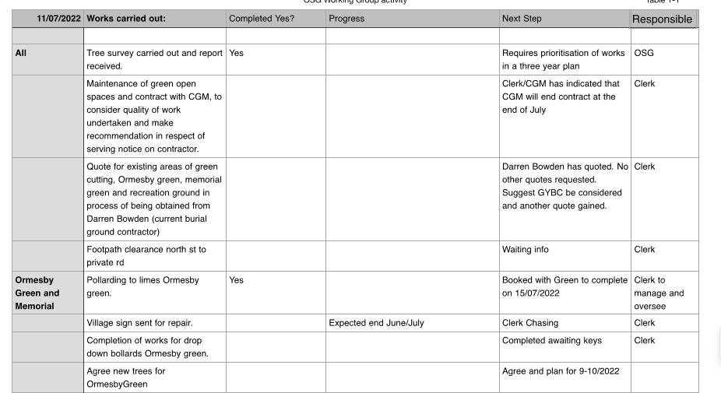

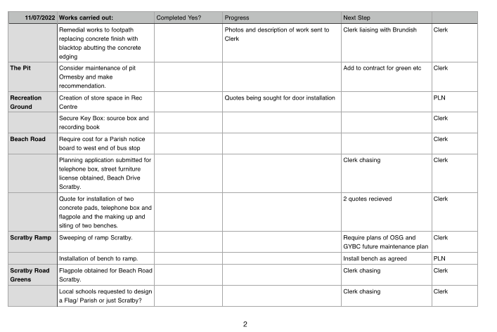
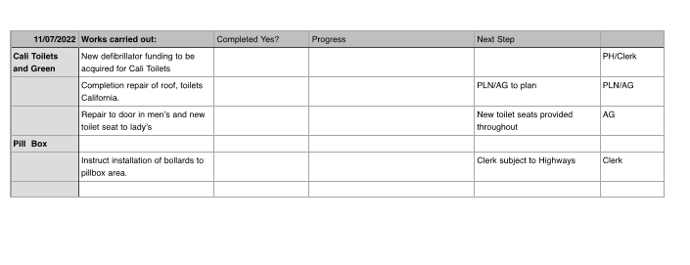
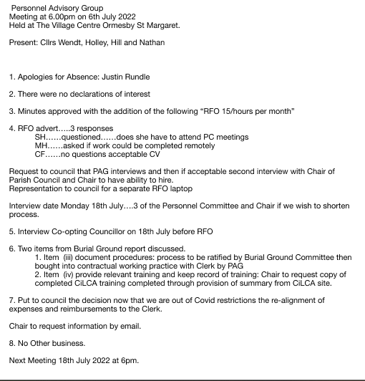

Ormesby St Margaret with Scratby Parish Council
Report of meeting of the Burial Ground Advisory Group
On Wednesday 6th July 2022 at 6pm
At the Village Centre Ormesby

- Attendance Cllrs: Kathryn Wendt, Robert Hill, Mick Cheetham and John Green.
Apologies for absence – Geoff Freeman

- Declarations of Interest for matters on the agenda – Cllrs: Kathryn Wendt and John Green re: Report.

- To elect a Chair of the new Burial Ground Advisory Group – Cllr John Green proposed Cllr Bob Hill. Cllr Kathryn Wendt seconded after a discussion regarding the future of the administration of the Burial Ground Advisory Group. Cllr Cheetham agreed Cllr Bob Hill’s position as Chair.
.

- Approve the minutes of the meeting held on 30th June 2022 – unanimously approved.

- To discuss Burial Ground Report:

2.3 of the report. To recommend to council to change the practice of reserving graves to purchasing graves to a maximum period of 100 years.
2.5 of the Report To recommend to council to adopt Appendix 1 and Appendix 2 of the report.
Recommendation to the council to repay the grave reservation relating to the burial ground incident in the sum of £200.00.
Recommendation to the council to pay Jary’s reduced invoice.
Recommendation to the council to pay Chris £50.0 for removal of the bench to enable re-burial.
The Burial Ground Advisory Group noted that training will be provided by the Personnel Advisory Group.

- Updating of Registers and Chart – Cllr Bob Hill stated that he would meet with Philip Stone parish clerk to update the Burial Registers and Chart.

