Ormesby St Margaret with Scratby Parish Council
Minutes of a meeting held on
Monday 13th January 2020, 7pm at The Village Centre, Ormesby St Margaret.

- Attendance: Present: Cllrs. Bigg, Freeman, Gingell, Green, Hill, Jones, Lee, Scott-Greenard, Shrimplin, Shulver, K. Wendt,
R. Wendt and County Cllr. Hanton. No members of the public attended. Chair: Cllr Adrian Peck.
Apologies (608.01.13) Cllr. Cheetham and Clerk: Jayne Morse (Minute Taker) due to illness. It was agreed that Cllrs Peck, K Wendt and Lee would take notes and produce draft minutes of the meeting in the first instance.
- Declarations of Interest for matters on the agenda (609.01.13)
Cllr Peck (Finance), Cllr Freeman (GYBC Development Control Planning Committee & Trustee of All Saints Parish Hall), and Cllrs Lee and R Wendt (Trustees of All Saints Parish Hall).

- Approve the minutes of the meeting held on Monday 9th December 2019 (610.01.13)
These were unanimously agreed and signed by the Chairman.

Public Forum (611.01.13)

Report from County Cllr. Hanton . Cllr Hanton detailed Norfolk County Council’s proposed £1m per year community fund, which had today been agreed in County Council cabinet as part of next year’s draft £282 million capital budget. The fund could provide grants of between £100,000 and £500,000 to groups wishing to invest in new community facilities. The draft capital budget was supported by Government grants of £124 million and borrowing of £157 million, which would pay for investment in property and equipment, including schools, extra care schemes and roads. The total proposed capital spend for 2020 – 2023 was £536 million.

Other highlights in the proposed capital budget included:
£39.2 million for adult social care, including Living Well extra care housing
£172 million for children’s services, including new special educational needs schools
£171 million for highways schemes, including the Gt Yarmouth third river crossing and A47 improvements (Acle straight dualling).

The budget would now move to the Scrutiny Committee on 28th January prior to presentation at full Council on 17th February.

Cllr Hanton detailed growing pressures on social care given the continued decrease in central government funding. Adult and child social care accounted for 70% of the County Council’s budget. He noted the current government green paper where it was hoped that need for increased funding in line with an ageing population would be recognised. The County Council also needed to allocate an additional £1m to cover a higher than expected increase in the National Living Wage. The current budget had been funded by a regrettable 3.99 % council tax increase, which included 1.99 % for general council tax and 2% under the government’s adult and social care precept.

4.2 Report from Borough Cllr. Scott-Greenard
Cllr Scott-Greenard reported that he had continued to query the failure of the developer to make good the currently unadopted road at the end of Pippin Close with the GYBC planning department. The development had since reached 100% occupancy in October 2019. He had made progress with one planning officer who confirmed that the necessary works should have been undertaken upon 40% occupancy, and that the developer was currently in breach of its s106 obligation with regard to the roadway.

4.3 Report from Borough Cllr. Freeman
Cllr Freeman reported that he too had been making enquiries concerning the Pippin Close site, which continued to be of concern. He had been notified of an accident to a parishioner as a result of the condition of the roadway. He had been advised by another planning officer that the department had been awaiting an overdue amendment from the developer.
As not adopted, that part of the road constituted a “public open space” and it was anticipated that each house on the development would contribute to the upkeep of the road through a legal charge.

During the Christmas period the drain at the bottom of Station Road next to the garage had continued to flood. This had been reported to Anglian Water via an app which monitored the progress of the job, together with a blocked drain on North Road.

Four instances of street lighting outages had also been reported via the dedicated GYBC email address.

Finally he noted that at Ormesby St Michael a green sign had been erected by the Broads Authority stating that the village was located within the Broads National Park area.

4.4 Public Participation:
None.

4.5 Police report:
None.

Matters Arising (612.01.13)

Following further investigation it was agreed that the grit bin placed at Beck Avenue Ormesby should remain in situ. It was agreed that a new grit bin should be requested on Beach Road, Scratby to be placed by the bus shelter at the junction with Beach Drive.

5.2 Cllr R Wendt reported that the Sam 2 (speed detection) cameras were ready for collection following a training course which he would be attending. Other interested councillors who were available to take training were asked to contact
Cllr R. Wendt.

Correspondence (613.01.13)

The Great Yarmouth Borough Plan had been sent by email on 18.12.19. Noted

6.2 The Dell
The new owner of the Dell, Nova Scotia Road had written to the Council concerning the trees that were causing problems with traffic on Yarmouth Road to confirm that they would be reduced in height to 12 feet and sided away from the road. - Noted

The Chairman reported that he had received a letter from a parishioner regarding an accident at All Saints Parish Hall. Receipt of the letter had been acknowledged and passed on to the Trustees. The matter would be discussed at the next parish council meeting.

Planning (614.01.13)

Notification of Decisions from Great Yarmouth Borough Council:
7.1 To receive notifications of decisions:
06/19/0473/F: 44 North Road (Orchard Court plots 5 & 6) Ormesby St Margaret, NR29 3LB. Vary condition 2 of Planning permission 06/18/0313/F (4 Houses and Garages to retain No 44 to allow developments of plots 5 and 6 only.
Approved 12/11/19.

06/19/0619/F: 911 North Road, Ormesby St Margaret, NR29 3SA. Demolition of existing hay barn and associated works. Approved 18/12/19.

06/19/0610/F: 26 Spruce Avenue, Ormesby St Margaret, NR29 3RY. Ground and first floor extensions and repositioned chimney. Approved 20/12/19
n
06/19/0586/F: “The Dog House”, Filby Lane Farm, Filby Lane, Ormesby St Margaret, NR29 3JS. Proposed single storey detached accommodation for a manager with office facilities. Approved 20/12/19.

Parish Council Comments on Applications received by Great Yarmouth Borough Council:

7.2 06/19/0635/F: 8-10 Filby Lane, Ormesby St Margaret, NR29 3JR. Change of use from retail premises to residential adjoining main house. No objection in principle but grey aluminium windows on the front façade are not appropriate in a conservation area.

06/19/0666/O: Foster Close, (Land to the rear of 70 Station Road) Ormesby St Margaret, NR29 3NH. One dwelling and garage plot. Objection:the council believes the renewal of permission should be deferred as the decision is entirely dependent upon achieving access through Foster close in relation to the main site planning application. At the present time with no access this is backland development .

06/19/0686/O: 27 Station Road, Ormesby St Margaret, NR29 3NH. Development of vacant land to create a single detached bungalow and garage- Revised submission. Objection. Back land development and access road not owned by applicant. There is no turning point so vehicles using the access to the Old Station and Jubilee Wood would have to reverse along the public footpath onto Station Road.

06/19/0678/0 Nova Scotia Farm (Land at) Jack Chase Way (West of) West Caister, Gt Yarmouth with all matters reserved, except access, for up to 665 dwellings: local centre (to include A1, A5 B1, D1 and other community uses); land for a primary school, health centre, plus associated infrastructure and open space.

The Council considered the above proposals insofar as they would affect the parish.
It was noted that Anglian Water had confirmed that the sewers north of Caister were are already full, and so objections based on this point could not be made.

Following discussion the Council noted its grave concerns regarding significantly increased traffic and highways provision, and the following statement was approved:
“Jack Chase Way is shown on all maps as the “Caister by Pass”
Prior to the construction of the bypass in the 1990’s during all the spring/summer months (April to September) the main road into Caister was a permanent traffic jam. Traffic would queue through the length of Caister village out to the Old Coast Road and as far back as Thoroughfare Lane Scratby.
The journey time to Yarmouth was usually in excess of one hour and often more. This was not an occasional but a daily occurrence.
The building of the bypass relieved Caister and the surrounding parishes of the misery of trying to drive into Great Yarmouth. Since that time there has been considerable development within Caister at Tessera Park and Pointers East, as well as three developments in Hemsby including the former Pontins site. In addition, although not “major” there are a number of developments in Scratby that also act to further serve to increase the traffic flow.
The design and access statement discusses the proposed new junction at Prince of Wales Road and the new roundabout at length. However, careful examination of drawing no E19824-TLP_PA02 Rev A and the document no 15 (Jack Chase Way) clearly indicates that including the current two roundabouts, one junction and one crossing on Jack Chase way(currently giving a total of 4) that this proposal will increase to 10 junctions /crossings and roundabouts on the bypass, also a reduction in the speed limit to 40mph will further slow traffic.
Local people will not wish to queue on Jack Chase Way and will find alternative routes via the two mentioned parishes. The issue is further complicated in that at the Tessera Park roundabout traffic heading towards Great Yarmouth is already regularly congested in giving way in both directions to the even larger streams of vehicles coming from the A149 and the Norwich Road.
We believe as Councillors and residents of this parish that this development will cause significant traffic issues within Ormesby in particular with Yarmouth Road, Station Road and Hemsby Road becoming rat runs for vehicles wishing to proceed either to Norwich via Acle or North to the Broadland Way (NDR). Local people knowing the situation will not wait and queue the length of Jack Chase Way.
The document states that the design statement was prepared following a traffic survey. However, it does not state when the survey was undertaken. Did the survey consider seasonal holiday traffic, what were the outcomes in traffic flows and were any of the historical issues with traffic delays taken into consideration? Have the developers considered any form of traffic calming measures on the roads mentioned above?
We also note that if the proposed school and/or doctor’s surgery are not built that the developers reserve the right to build further properties on the site. This will further exacerbate the traffic problem.
In summary the Council considers that this development has the potential to seriously affect the majority of the northern parishes (in particular Caister and Ormesby) in a negative way. Jack Chase Way will no longer act as a bypass for Caister. This Council requests that it should be consulted with to ensure that the views of the parishioners whom it represents are fully taken into account before this application is approved.”

Finance (614.01.13)
With the consent of the meeting it was agreed that this item be moved to later in the agenda.

9 Parish Plan (615.01.13)  Councillors had received a presentation from Collective Community Planning and noted the benefits of producing a parish plan. It was resolved to seek a grant of £8,950 from GYBC in order to produce a parish plan. It was further resolved that should the grant be successful, that Collective Community Planning be commissioned to assist with its preparation. | Proposed: Cllr. Gingell  Seconded:  Cllr. Jones  Unanimous
Recreation Ground and Playground Working Party (616.01.13)  Cllr. Scott-Greenard reported that the working party had prepared a Temporary User Agreement between the Council and Ormesby Lads. The agreement as presented to the meeting was discussed and approved in principle. A meeting of the chair and vice chair of the working party was to be held with Ormesby Lads on Tuesday 14th January 2020.  Following the recommendation of the working party, it was resolved that Cllr Shulver be elected onto the working party.  It was noted that the previously approved Terms of Reference for the working party did not allow the inclusion of community volunteers. It was therefore resolved that paragraph 1(d) of the working party’s Terms of Reference be amended to add the following additional sentence: “The working party will also co-opt non-voting community volunteers as it sees fit”.  The consultation over the future of the recreation ground was going well with 60 responses to date. Finally, the charitable constitution for the proposed Community Interest Group had not yet been registered with the Charities Commission as unfortunately the website was down over Christmas. | Proposed: Cllr. Scott- Greenard  Seconded:  Cllr. Hill  Unanimous  Proposed: Cllr. Scott- Greenard  Seconded:  Cllr. R Wendt  Unanimous
Finance and General Purposes Committee Minutes. (617.01.13)  The draft minutes of the F & GP held on 16th December 2019, circulated prior to the meeting were adopted by the council in full. | Proposed:  Cllr. Gingell  Seconded:  Cllr. Jones  Unanimous
- Personnel Committee (618.01.13)
It was agreed that this item be discussed “In Camera” at the end of the meeting.
- Minutes- Format and Presentation (619.01.13)
This was not discussed as the Clerk was not in attendance.
- Speeding (620.01.13)  Cllr Freeman suggested that a speed management strategy for the parish should be implemented | Agreed
15 Ongoing open agenda item for discussion and update regarding the need to replace Scratby Steps (621.01.20)  Cllr Peck reported that works were due to start on Monday 20th January to replace the steps with a ramp. The total cost of replacement from Munnings Construction was £34,707.86 plus VAT. Pledged money from Park Dean Resorts was still awaited but an email had been sent by the Chairman to the General Manager requesting payment. Confirmation that GYBC had agreed to grant £15,000.00 had been forwarded by Cllr Freeman to the Chairman.  It was agreed to use the funds from the reserve account to pay for the steps whilst a decision from the GYBC Bid was awaited. | Proposed:  Cllr. Freeman  Seconded:  Cllr. Jones  Passed 12 votes for, 1 absention  Cllr Bigg

16. Ongoing open agenda item for discussion regarding Coastal Erosion (622.01.13)
There was nothing to report on this occasion.

Training – Planning Process. (623.01.13)
It was agreed to put this on February’s agenda.

“S100 Legislation”
Referring to the F&GP minutes, Cllr Freeman confirmed that he had received from the monitoring officer the appropriate wording concerning the exclusion of the public from meetings under S1(2) of the Public Bodies (Admissions to Meetings) Act 1960. This had been forwarded to the clerk but would in her absence be sent to the Chair.

Matters for reporting:
Cllr Green reported that the roof of Dyble’s garage and the radio mast were both in need of attention. Cllr Peck agreed to take the matter up with the landlord and the Esso garage management.
Matters for next Agenda:
Councillor training.

20. Finance (614.01.13)
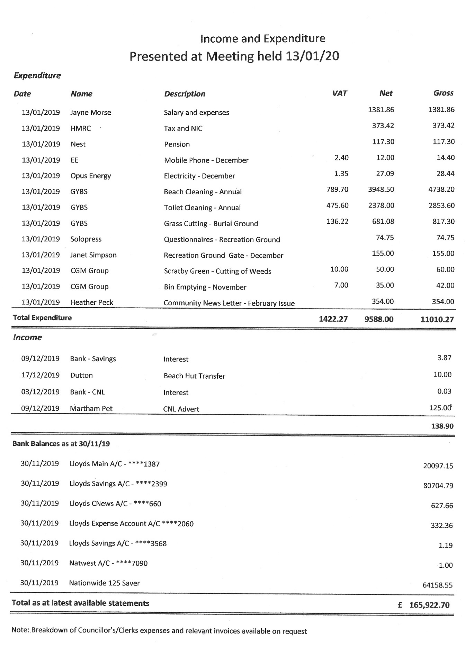
Having regard to the statement of income and expenditure presented to the meeting and included within these minutes, it was resolved:
20.1 To authorise the month’s expenditure and to note receipts  20.2 The following transfer of monies was agreed:  £11,000 from ****2399 to ****1387  20.3 Transfer of £9,357.35 plus £1,871.47 Total £11,228.82. From ****2399 to Natwest account. | Proposed:  Cllr. Green  Seconded:  Cllr. R. Wendt  Proposed:  Cllr. R. Wendt  Seconded:  Cllr. Bigg  Proposed:  Cllr. Hill  Seconded:  Cllr Jones
County Councillor Hanton left the meeting.

21 Personnel Committee  It was resolved that in accordance with S1(2) of the Public Bodies (Admission to Meetings) Act 1960 that the public be excluded from the meeting for consideration of this item as publicity would be prejudicial to the public interest by reason of the confidential nature of the business to be considered. | Proposed:  Cllr. Shrimplin  Seconded:  Cllr. K. Wendt  unanimous
The public meeting closed at 9.31pm.

The next Parish Council meeting will be held on Monday 10th February 2020 at The All Saints Parish Hall, Scratby at 7pm.

Ormesby St Margaret with Scratby Parish Council Draft minutes published 21/1/20

_______________________
Chair

