Minutes of a meeting of Ormesby St Margaret with Scratby Parish Council
Held at 7pm on Monday 10 February 2020 at All Saints Parish Hall, Beach Road, Scratby.

Present: Cllrs. Bigg, Cheetham, Freeman, Gingell, Green, Hill, Jones. Lee, Scott-Greenard, Shrimplin, Shulver, K. Wendt,
R. Wendt, County Cllr. Hanton.
No members of the public. Chair: Adrian Peck. Clerk: On sick leave

- To accept apologies for absence (624.02.20): None

- Declarations of interest (625.02.20): Cllr. R Wendt on finance. Cllrs. Freeman, Hill, Shrimplin and Bigg as allotment holders.

Approve minutes of the 13th January 2020 (626.02.20): The minutes having been previously distributed were declared a true record and duly signed by the Chairman. Agreed

- Public Forum (627.02.20)

4.1 County Cllr. Ron Hanton:
Boundary Commission
Cllr. Hanton reported that the Boundary Commission was currently reviewing the division arrangements for Norfolk County Council. The review was triggered as a result of over 30% of the current divisions being outside of the 10% variance required, leading to elector inequality. Currently, NCC had 84 councillors and it was anticipated that this would remain.

Initially, the deadline for submissions was 11 February and NCC submitted its recommendations using the agreed methodology, which created 72 new or amended divisions, with only 12 of the 84 of remaining unchanged. NCC was due to vote on these proposals on 3 February 2020.

However, late on 31 January 2020 the Boundary Commission advised that South Norfolk District Council had submitted queries concerning projected future housebuilding in that District. Consequently, the Commission decided that NCC’s submission for the whole of Norfolk would have to be re-worked using a revised methodology. The revised date for NCC submissions was now 24 March 2020.

Extension to Caister Transfer Station
During the month Norfolk County Council allocated funding for a proposed extension of Caister Transfer Station (owned by Norfolk County Council and operated by Norse Environmental Waste Services).

The site had come under increasing pressure due to the age of the current facility, limited available space and increasing demand. The upgraded transfer station would ensure the facility was fit for the future by providing additional space for segregation of waste and a new fire prevention system.

NCC was working on the plans for the extension before finalising them for a planning application. The plans included an additional building next to the existing transfer station on the site of the old recycling centre, designed to enable the site to continue operation during construction of the new site.

These proposals would be going out for public consultation and following feedback, the planning application will be finalised and submitted to Norfolk County Council planning services. The proposed timetable was:

April 2020 – Planning Application Submitted
August 2020 – Planning decision received
October 2020 – March 2021 – Construction period
April 2021 – new building opens

An application would also be made to the Environment Agency to vary the operating permit to account for the extended operational area. There would be further opportunity to comment on the proposals as part of the statutory planning and permitting processes.

4.2 Borough Cllr. Geoff Freeman:
Demolition had now started on the Marina Centre. The town centre plan has been well received with the market traders and the local businesses in support. The third river crossing has now passed the final planning hurdle so preparation for a start date could continue. Both elected members and officers from the borough, together with all the MPs with constituencies along the A47 had been to London to make representation with regard to the dualling of the sections that have been agreed with highways England (Burlingham and Easton). The start date was planned to be 2021. Cllr Freeman would be meeting with GYBC officers on Wednesday with regard to the proposed toilet refurbishment at Scratby.
Locally the street lighting teams had been present and the majority of the lamp standards had been brought back into service. However, there were always outages which would continue to be reported. Dangerous trees on Yarmouth road have been reported to the landowner. Finally, Cllr Freeman had received positive reactions from constituents to the SAM2 camera placed on Cromer Road.

4.3 Borough Cllr. Scott Greenard.
Cllr. Scott Greenard had been on holiday and had nothing substantive to report. A “report it” request had been made to GYBC in respect of full rubbish bins on Sharpe Way, Ormesby. Pippin Close had been resurfaced by the developer to an acceptable standard. Now this was in place Norfolk County Council Highways dept should be asked to address the issue of kerb placement.

Public Participation Forum:

No members were present.

6. Matters Arising (628.02.20)
Grit Bin:- Awaiting reply from the Borough Council for a bin to be placed by the bus shelter, Beach Road and another California Road near The California Tavern.

Speed Awareness Messaging Sign (SAM 2) - Cllr. R Wendt confirmed that a new SAM 2 had been placed on Cromer Road, Ormesby on 24th January 2020. It must be moved to another of the 4 sites after 4 weeks. Cllr. R Wendt and Cllr. Hill had attended the SAM 2 training course on 21st January 2020. Cllr R Wendt reported the data received so far which indicated that only 57% of the 20,000 cars passing through during the 11 days captured were within the speed limit of 30 mph. The Chair thanked Cllrs. R Wendt and Hill for the work they had done.

- Correspondence (629.02.20)
Email – Report of accident at All Saints Parish Hall (ASPH). Cllr. Peck reported that he had informed the Trustees of the hall. Cllr. Freeman, Chair of the trustees reported the accident to the parish council’s insurance company but had heard nothing back. He would chase up the insurance company for a reply.
Email – Ormesby Bowls Club. Requesting an answer to their email of 21st June 2019 with reference to mirrors being placed at the two exits from the recreation ground. Unfortunately it appeared this email had been received but not reported to Council at the time. Matter passed to the Recreation and Playground Working Party.
Email – Request for a beach hut on Scratby Green when one becomes available. Noted.
Email- Received from Groundwork UK. Grant of £2,300 towards the development of the evidence base and consultation in respect of the Parish Plan confirmed for 2019/20. Noted.

Burial Ground Bin - Cllr. Cheetham reported that a parishioner had complained about the smell of the bin prior to emptying. It was decided that the matter be referred to the Burial Ground Committee.

- Planning (630.02.20)
Notification of Decisions from Great Yarmouth Borough Council:
06/19/0441/F: 32b Beach Road (Land adj.) – Sub-division of garden to form 4.plots for detached bungalows and garages. Approved.

Parish Council Comments on Applications received by Great Yarmouth Borough Council:
06/18/0261/F: 14 Beach Road, Scratby: 8 new dwellings 4, 2 bedroomed terraced houses, 3, 2 bedroomed detached houses, 1, 3 bedroomed detached bungalow. Objection. Safety and on the same lines of the previous objection plus request a Management Committee/site visit and highways engineer visit to view visibility and mention bus stop across from site.
06/19/1706/F: 5 Dowe Hill House, Scratby Road, Ormesby. Proposed single storey extension with roof terrace to rear. No objection.
06/19/0717/F: Nova Scotia Road,Ormesby. Proposed two storey residential dwelling. No objection

Finance (631.02.20)
The following statement of income and expenditure was circulated to the meeting:
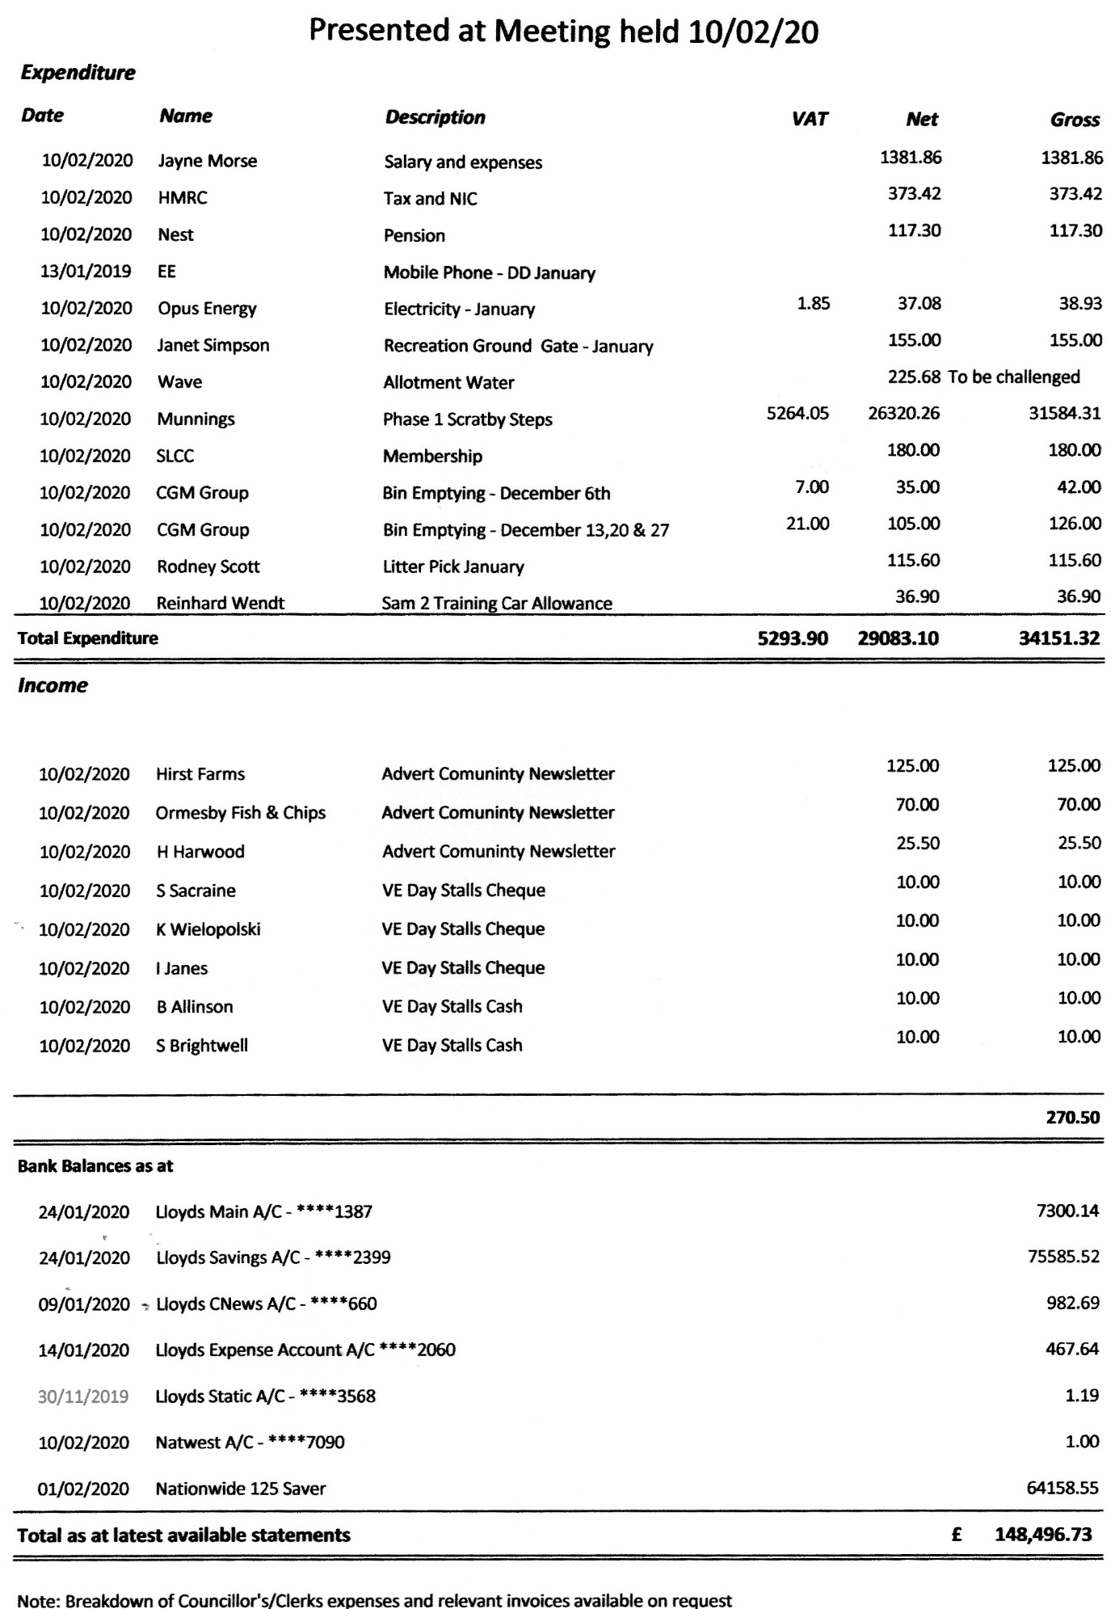

It was noted that:

Payment to Rodney Scott for January’s litter pick should be £115 not £136
Water bill of £225.68 for the allotments was incorrect: Cllr. Freeman to investigate
Cllr. Lee confirmed that the membership subscription for the Society of Local Council Clerks was paid by the Council
The Clerk’s salary figures were subject to final adjustment

In the absence of the Parish Clerk, Cllr K Wendt thanked Cllr. Peck for the work he had done to prepare the accounts for the meeting.
The Monthly expenditure was approved subject to the above adjustments.
Proposed Cllr. Jones seconded Cllr. Cheetham- unanimous.

Transfer of £30,000.00 from ****2399 to *****1387 Proposed Cllr. Shrimplin, seconded Cllr. Hill

In the light of the above adjustments the bank reconciliation could not be agreed at this meeting. The bank reconciliation and bank account balances would be subsequently reviewed by Cllr. Gingell.

Recreation and Playground Working Party report (632.02.20)
Notes of a meeting of the working party held on 6 February 2020 were circulated to the meeting and duly noted. It was agreed that a letter in the form circulated to the meeting be sent to the Ormesby Lads committee, setting out the Council’s powers to restrict use of the ground for groups and individuals. The draft letter was approved: Proposed Cllr Scott-Greenard Seconded Cllr Jones. Unanimous. Cllr Scott-Greenard has replied to the Bowls Club with regard to the poor state of the car park, requesting copies of the club’s accounts.

Personnel Committee Report (633.02.20) It was agreed that this item be taken in camera at the end of the meeting.

Scratby steps. (634.02.20)
Cllr. Peck reported that work had started on the steps at Scratby and phase two (surfacing, kerbs and the addition of a drop down coded bollard) was expected to finish by the end of March. It was agreed to ask Barrie Burgess, of Technicus Consulting to check the works when completed and authorise the parish council to make payment.

13 Parish plan. (635.02.20)
Cllr. Peck reported that work could now start on the initial phase of the Parish Plan as the grant of £2300 from Groundwork UK had been approved for 2019/20. It was agreed to that any clawback time limits as to when these funds should be spent be clarified for the next meeting.

14 Royal Mail post box, Ormesby. (636.02.20)
Cllr. Shrimplin reported that the post box at the old post office on Cromer Road had been removed and there was no replacement at the new post office at the Spar shop on North Road. Council had already agreed to support the Spar shop for a post box to be installed on the green space at the entrance to Ranworth Drive which had been refused. A further letter to be sent to the rural delivery manager, Royal Mail.

15 Allotment Working Party Report (637.02.20)
Notes of a meeting of the working party held on 25 January 2020 were duly noted. A quotation for cutting back the hedge and the ivy at the allotments by GYBS of £357.70 + VAT had been obtained by Working Party. Councillors questioned that there should be more than one quote. Cllr. Freeman said that he would speak to more contractors but felt that the price was a good one.

Cllr. K Wendt proposed and seconded by Cllr Scott-Greenard unanimously passed for the work to be done.

16 Training (638.02.20)
Cllr. K Wendt said that she had spoken to 5 training providers. Norfolk Parish Training and Support seemed the best as they are a group of three experienced clerks. The cost would be in the region of £500 which was within budget. They had delivered training to some Councillors who had found the sessions very useful. Cllr. K Wendt said that it would be a full day’s training with lunch provided. It was agreed that the training would take place on a Tuesday in May 2020 and Cllr. K Wendt would email Councillors with the date once agreed with the trainers and All Saints Parish Hall.

17 To open ongoing agenda item and discussion regarding coastal erosion (639.02.20)
No Report

18 Diary Dates (640.02.20)
Cllr. Gingell was thanked by the Vice Chair for preparing the parish council meeting diary dates for two years. These were noted with a change of one date from 13 April 2020 to 6 April 2020.

19 Matters for reporting:
A parishioner had offered to pay for a wooden bench at the recreation ground. Council will follow this up.
Cllr. Lee stated that the Resilience Plan needed updating.

20 Matters for next agenda:
Cllr. Lee stated that the Resilience Plan needed updating.

21. Date of next meeting:
The next Parish Council meeting will be held on Monday 13th March 2020 at The Village Centre, Ormesby, starting at 7pm.

22 Personnel Committee Report
It was resolved that in accordance with S1(2) of the Public Bodies (Admission to Meetings) Act 1960 that the public be excluded from the meeting for consideration of this item as publicity would be prejudicial to the public interest by reason of the confidential nature of the business to be considered.

Proposed Cllr. Peck and Seconded Cllr. Green. Unanimous.

The public meeting closed at 8.55 pm

Signed: Published: 15 February 2020

