Hemsby information event

FREE REFRESHMENTS
Thursday 21st June 2018 9.30am - 12.30pm
Barn Room, The street, Hemsby NR29 4EU
Come along and find Information from:
Norfolk Library service
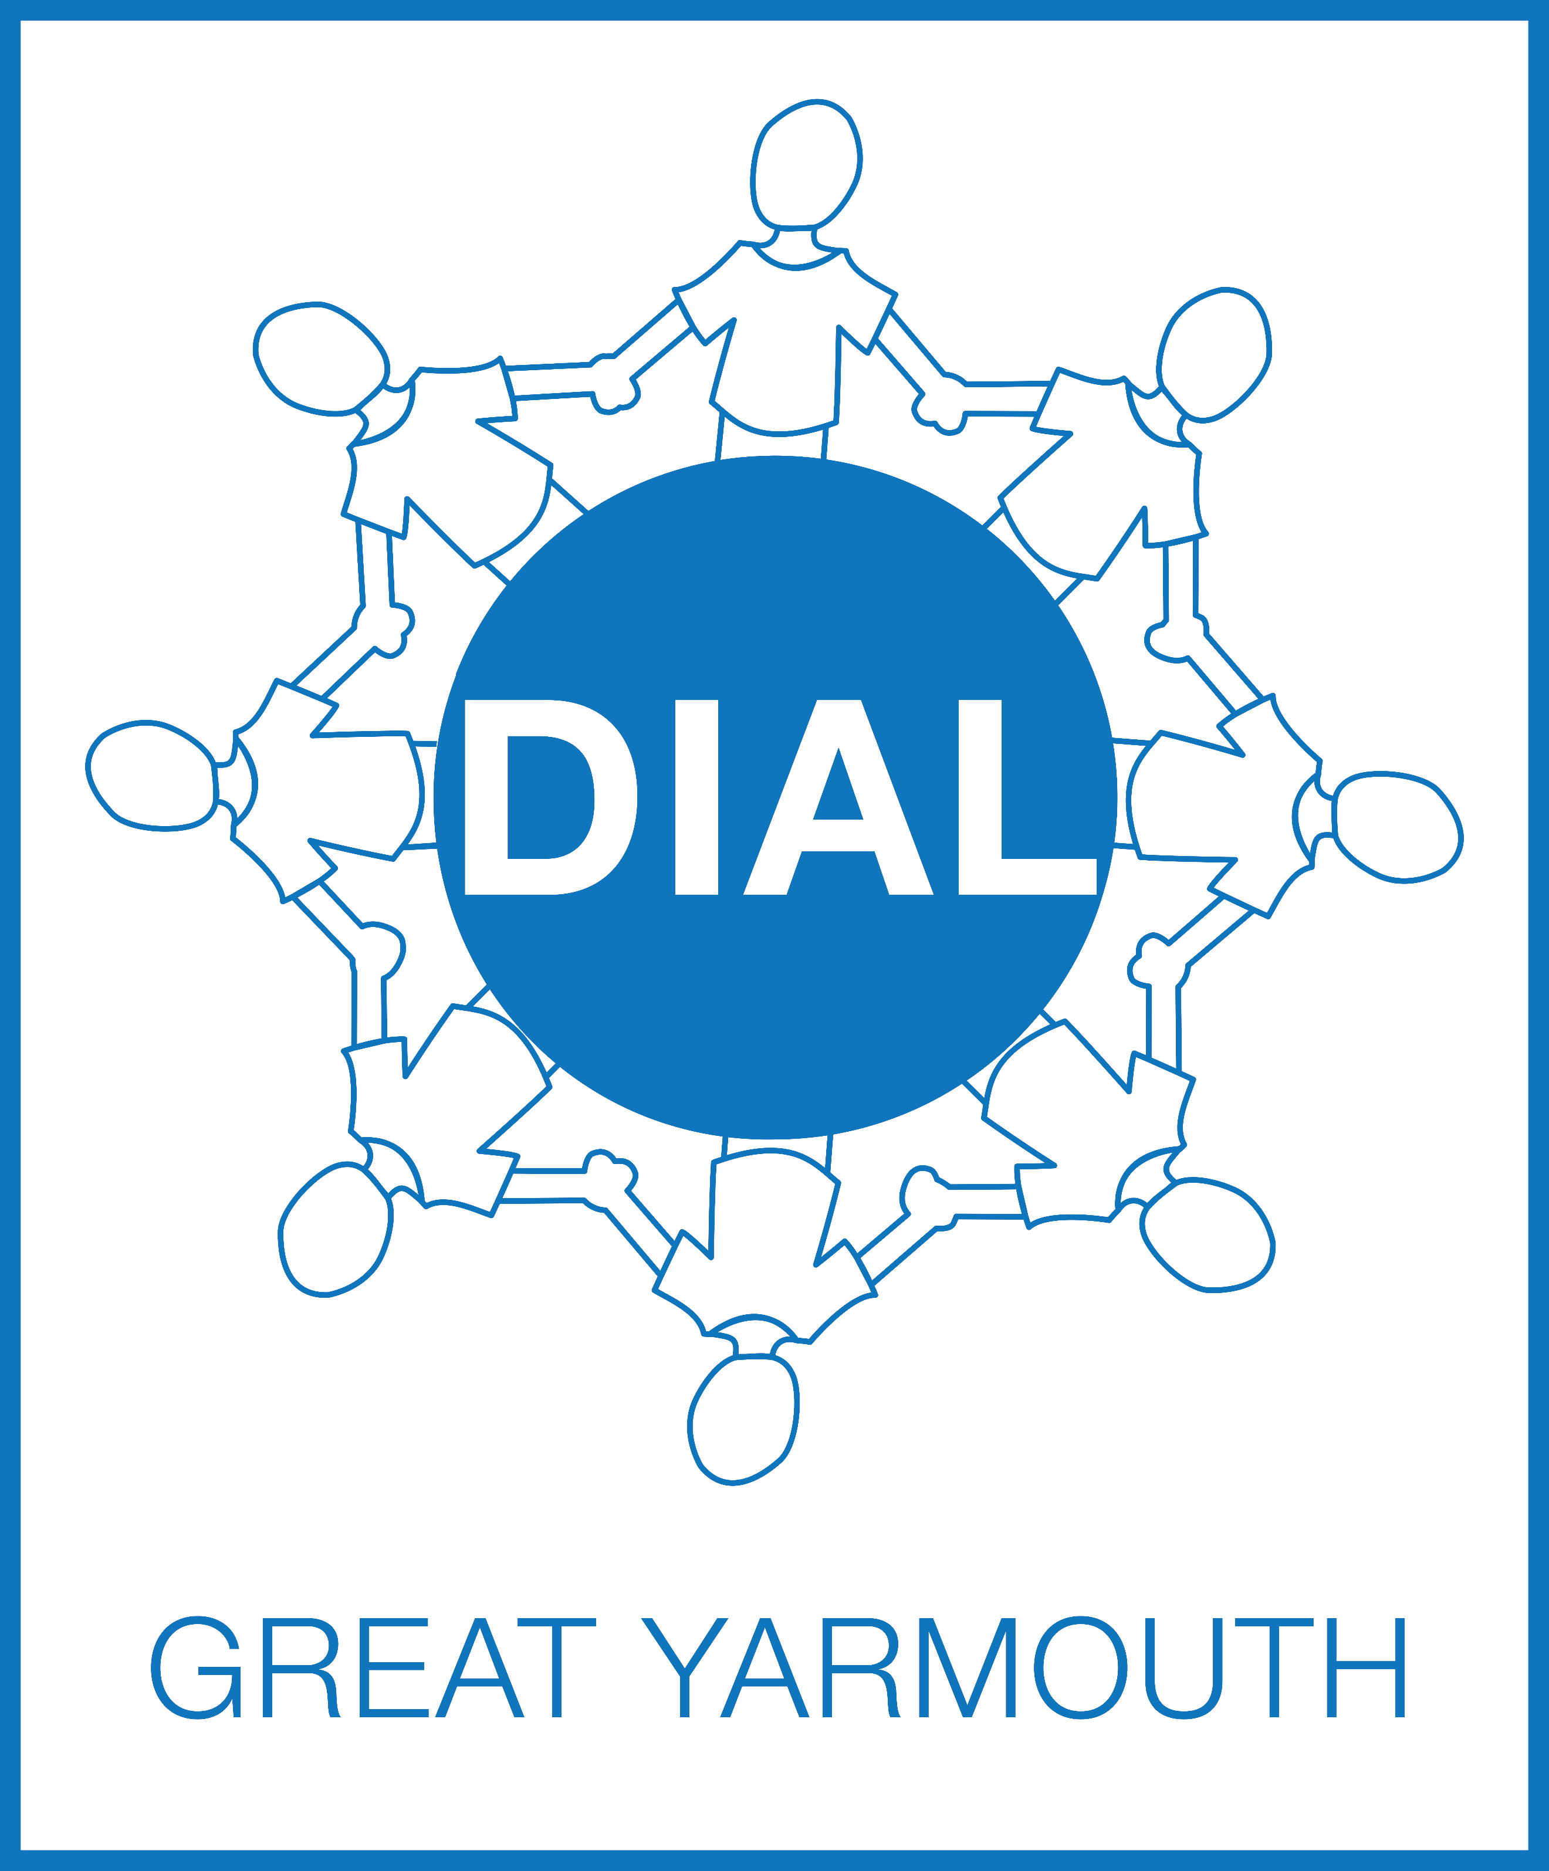
DIAL
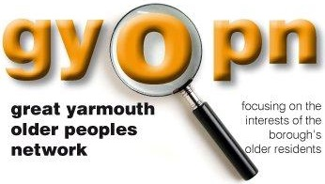
GYOPN

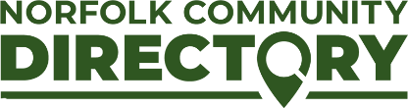
Norfolk County Council
Prevention Services

Sponsored by Hemsby Parish Council

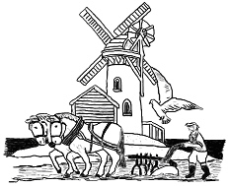 | Parish Office Kingsway  Hemsby  Great Yarmouth  Norfolk  NR29 4JT  All correspondence please to:  The Parish Clerk  Elaine Galer Tel 01493 719235  Email: clerk@hemsbyparishcouncil.org..uk

